Designer Wedding Wear for Women 2026 Bridal Style Guide
By Sugandh Gupta | September 5, 2026
Every wedding season brings this same half “list” of questions, what to wear for haldi, what works best for sangeet, and which outfit finally gets the spot as the wedding day look. But picking designer wedding wear for women isnt only about chasing trends , it is also comfort… like you have to feel right through a twelve hour thing, still look polished in every photo, even when you are dancing or just standing there and smiling like its easy.
So this guide kind of goes through the whole set of wedding outfits for women you might actually need in 2026, starting from haldi, then the mehendi , then everything after… like the last post wedding brunch too. You will also get fabric advice, styling angles, and small practical tips to pick pieces that match your body type, your budget, and the mood of each function, not just one single event.
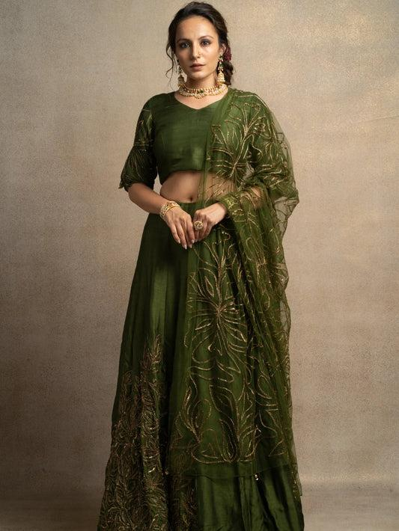
Why designer wedding wear matters more than ever
Weddings now rarely stay in one moment , they spread across three , four, sometimes five different functions and every stop has its own dress code energy. That is why designer wedding wear for women has moved away from one heavy outfit you wear once, and then its done. Now its more like a small wardrobe… almost like a trousseau where pieces actually mix together, instead of feeling random.
Good designer wedding wear does a few things at once: it handles studio lighting and daylight photos, it stays comfy through standing , dancing and greeting people, and it still looks like you not like you borrowed a costume. If you invest in well made wedding outfits for women instead of one off rentals, you also get the bonus that you can restyle for festive nights , anniversaries, and family events for years.
Types of wedding outfits for women in 2026
Not every function wants the same silhouette. Here’s the big categories of designer wedding wear you will keep seeing, and re wearing, season after season.
Silk Kurta Sets
Silk kurta sets stay one of the most flexible options among wedding outfits for women, they feel dressy enough for a wedding lunch , but way easier to move in than a full lehenga. Deep jewel tones, zari borders, and a matching dupatta make them a solid pick for mehendi lunches , post wedding pujas, and family dinners where comfort matters almost as much as the look.
Bridal Anarkali Sets
The Anarkali shape keeps winning designer wedding wear because the flared cut suits nearly every body type , and still gives that natural drama when you walk or twirl. Floor length Anarkalis in silk or georgette, finished with hand embroidered yokes , fit beautifully for wedding day or reception, when you want it to feel complete, not rushed.
Lehengas and Indo-Western Gowns
For the main ceremony or a cocktail style reception, layered lehengas and more structured Indo Western gowns bring the volume and shine that heavier functions expect. Pair your lehenga with a cape style dupatta, or go for a fitted gown with statement sleeves, for a more modern take on bridal wedding wear.
Kaftans for destination and resort weddings
Since more Indian weddings are happening at beach or resort venues , flowy kaftans have earned a true place in designer wedding wear for women. They are lighter than a kurta set, need almost no extra styling, and still have enough embroidery or print detail to belong in wedding land , not just read like basic beachwear.
Angarkha sets and sharara suits
For brides and close family who want something between a kurta set and a full lehenga, Angarkha style sets and sharara suits are worth thinking about. The wrap front Angarkha silhouette plus flared sharara pants bring movement to wedding outfits for women , without the heavy layered feel of a traditional lehenga, so it can be a comfy option for sangeet or even a daytime reception.
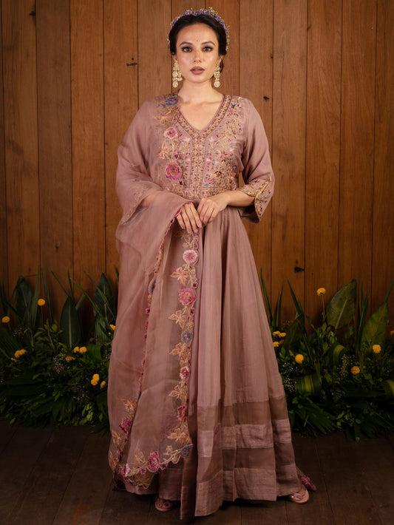
Wedding wear by ceremony what suits each function
One of the biggest questions brides and guests ask is how to split your trousseau across ceremonies, without over packing or under dressing. Here’s a function by function breakdown of designer wedding wear that works in real life, not only in perfect lookbooks.
Haldi and Mehendi
For these daytime events you want lighter fabrics and brighter shades. Yellow, marigold , and mint georgette kurta sets, or pre draped Indo Western sets, let you move through the rituals and still end up dancing, without heavier embroidery feeling too much.
Sangeet and cocktail night
This is where designer wedding wear for women can go extra. Think sequin work, cape style jackets, and metallic dupattas that actually catch the light. Fusion kurta sets with high slits or peplum cuts look great with statement earrings, and they still give you room to move, so the glam doesn’t drop halfway through the night.
Wedding day and reception
This is where your most elaborate wedding outfits for women come in, heavy zardozi kurta sets, silk Anarkalis, or a bridal lehenga, depending on your role and how dramatic you want the look. Go for fabrics like pure silk or organza, because they hold structure well and photograph beautifully under evening lighting.
Fabric Guide Choosing the Right Base for Wedding Wear
Okay so, the fabric under the embroidery kind of matters a lot, maybe almost as much as the design it self. When you’re looking for designer wedding wear, keep an eye on these basics, and don’t just go by the photos.
● Pure Silk: gives that proper structured drape and natural sheen, it’s really good for evening functions and heavy embellishment,
● Georgette: light and easy, with a breezy movement, great for daytime ceremonies like haldi and mehendi
● Organza: crisp, airy, and kind of voluminous, works well for capes, dupattas, and layered lehengas
● Silk Blends: that practical middle step between luxe and simple upkeep, you’ll see this a lot in mid-range wedding outfits for women
How to Choose Designer Wedding Wear for Your Body Type
Color and fabric are nice, but fit is what makes designer wedding wear look “effortless” on camera. Like it should sit well when you stand still, but also behave when you sit, walk, and do all the things.
Consider Your Silhouette
● A-line and Anarkali cuts usually flatter most body types, and they bring in gentle volume too
● Straight-cut kurta sets are a solid match for petite frames, without making the whole look feel too much
● Structured lehengas, especially with fitted blouses, work really well for hourglass and pear shapes, so the silhouette stays balanced,
Accessorize with Intention
Accessories can either elevate, or make it feel crowded, so choose with some calm confidence
● Pick statement Kundan or Polki jewelry for the wedding day and the reception
● For haldi and mehendi, go with delicate jhumkas or even simple studs,
● Add an embellished potli bag, and block heels if you want comfort through long sangeet nights
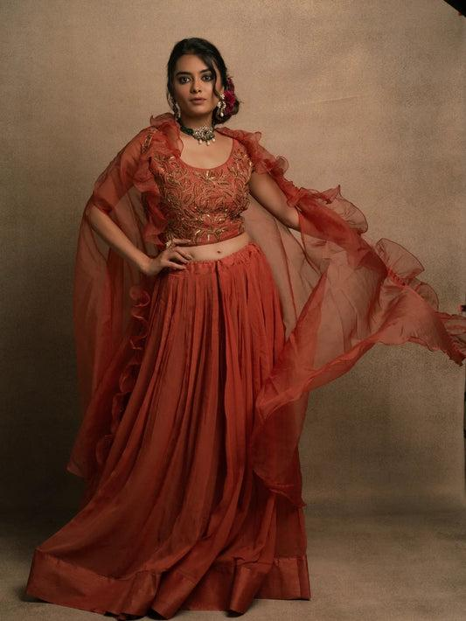
Styling Tips for Designer Wedding Wear
An outfit is only half the story, styling decides if it looks effortless or kinda overdone (and trust me, it shows in pics)
● Team a heavily embroidered kurta set with minimal jewelry, so the handwork becomes the real main character
● Add a contrasting dupatta over a solid-color lehenga for depth, without piling on extra embellishment
● For daytime wedding outfits for women, keep makeup slightly muted, then go bolder for evening functions
● Skip stilettos if you’ll be standing through long rituals, choose block heels or embellished flats instead
Caring for Your Designer Wedding Wear
Hand-embroidered wedding outfits for women are definitely investment pieces. So a little care goes a longer way, like way longer
● Choose professional dry cleaning, it helps protect metallic threadwork and delicate silk fibers
● Don’t hang heavily embroidered pieces for storage, fold them with acid-free tissue paper instead, because weight can stretch the fabric over time
● Keep them in breathable muslin bags, away from direct sunlight and moisture

Frequently Asked Questions
What is the difference between wedding wear and regular party wear?
Designer wedding wear usually leans into richer fabrics, heavier hand-embroidery, and more structured silhouettes than regular party wear. It’s basically made to stand out in wedding photography while still being wearable across longer functions,
How many outfits do I need for a multi-day wedding?
Most trousseaus include, a lighter set for haldi or mehendi, a statement piece for sangeet, the most elaborate wedding outfit for the main ceremony or reception, and one comfortable option for post-wedding visits.
Which fabric works best for a summer wedding?
Georgette and lightweight silk blends drape beautifully and stay breathable, so they’re a smart option for daytime or summer wedding outfits for women
Can designer wedding wear be reused after the wedding season?
Yes. Silk kurta sets, and Anarkalis in particular, can be restyled easily for festive occasions, family functions, and even anniversaries well after the wedding

Final Thoughts
Choosing designer wedding wear for women doesn’t mean you have to start from scratch every single function. When you blend the right fabrics, silhouettes, and a few versatile wedding outfits for women that move across ceremonies, you end up with a trousseau that feels planned, not rushed.
Browse the full designer wedding wear collection curated by World of Sugandh, to find the outfit that matches your next celebration. If you already know the silhouette you want, you can also check out specific edits like wedding kurta sets or silk kurta sets

About the Author
Sugandh is a passionate fashion writer with more than 8 years of experience in Indian ethnic wear, focusing on bridal and festive styling. Read more on the About Us page, or stay in the loop on Instagram and YouTube.

